ST. ERVAN PARISH COUNCIL
Jacqui Peskett
Parish Clerk

Email: stervanpc@outlook.com
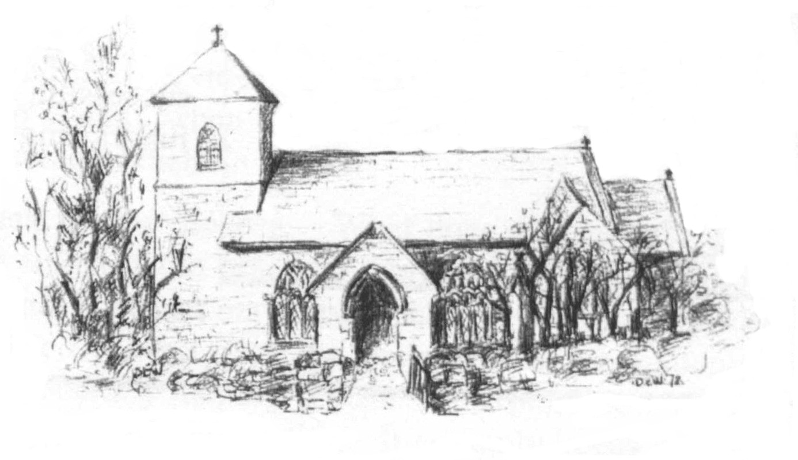

5th October 2023

I hereby give notice that the EXTRA - ORDINARY MEETING of ST ERVAN PARISH COUNCIL will be held at St Ervan Village Hall on Tuesday 17th October at 7.00pm

All members of the Council are herby requested to attend for the purposes of considering and resolving upon the business about to be transacted at the meeting as set out in the agenda.

Cllr Roger Biddick
Chair of St Ervan Parish Council

Public Participation
Representatives in attendance in respect of Planning Application PA23/05460

AGENDA

Apologies and Announcements

Declarations of interest

Planning Applications

Erection of buildings for use as a broadcasting/recording studio, post-production facility and related modular serviced accommodation, car parking, servicing, landscaping, access improvements and other related infrastructure
Old St Merryn Aerodrome The Old Airfield St Merryn Padstow Cornwall PL28 8PT
Ref. No: PA23/05460 | Received: Tue 04 Jul 2023 | Validated: Fri 15 Sep 2023 | Status: Pending Consideration

Date Of Next Meeting: Tuesday 7th November 2023 @ 7pm

